SOFTWARE ENGINEERING LAB TASK

UML (USE CASE DIAGRAMS)

HU22CSEN0100287

Sai Ganesh Eswaraprasad

CLINIC (1st img) AND BANK ATM (2nd img)

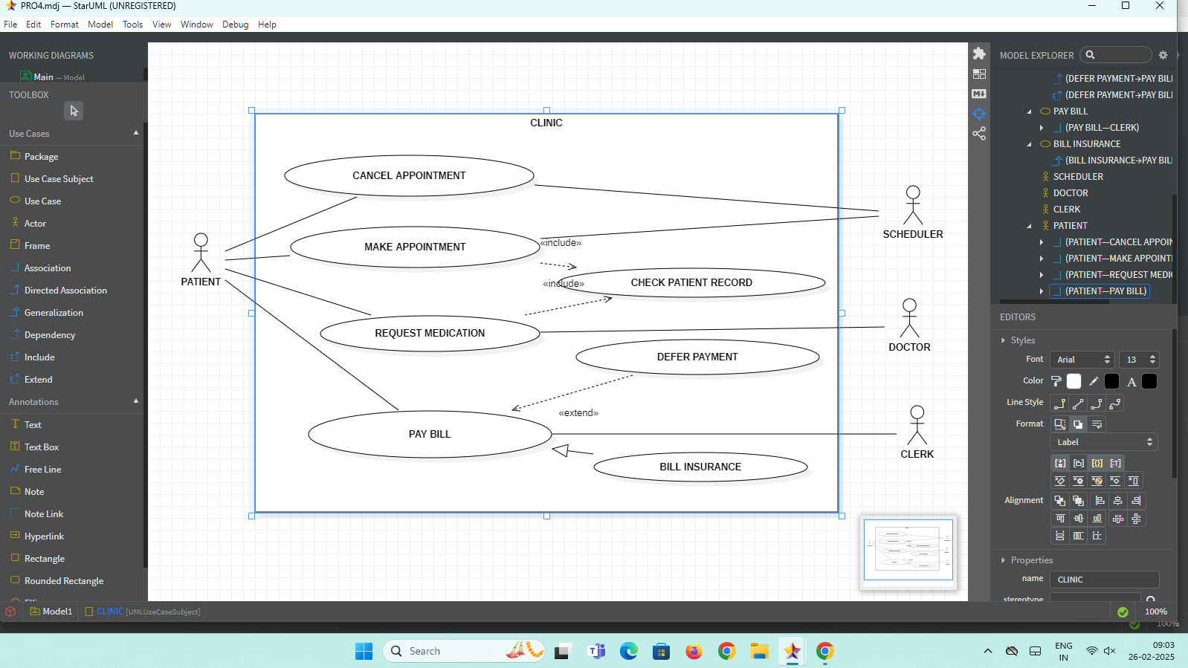

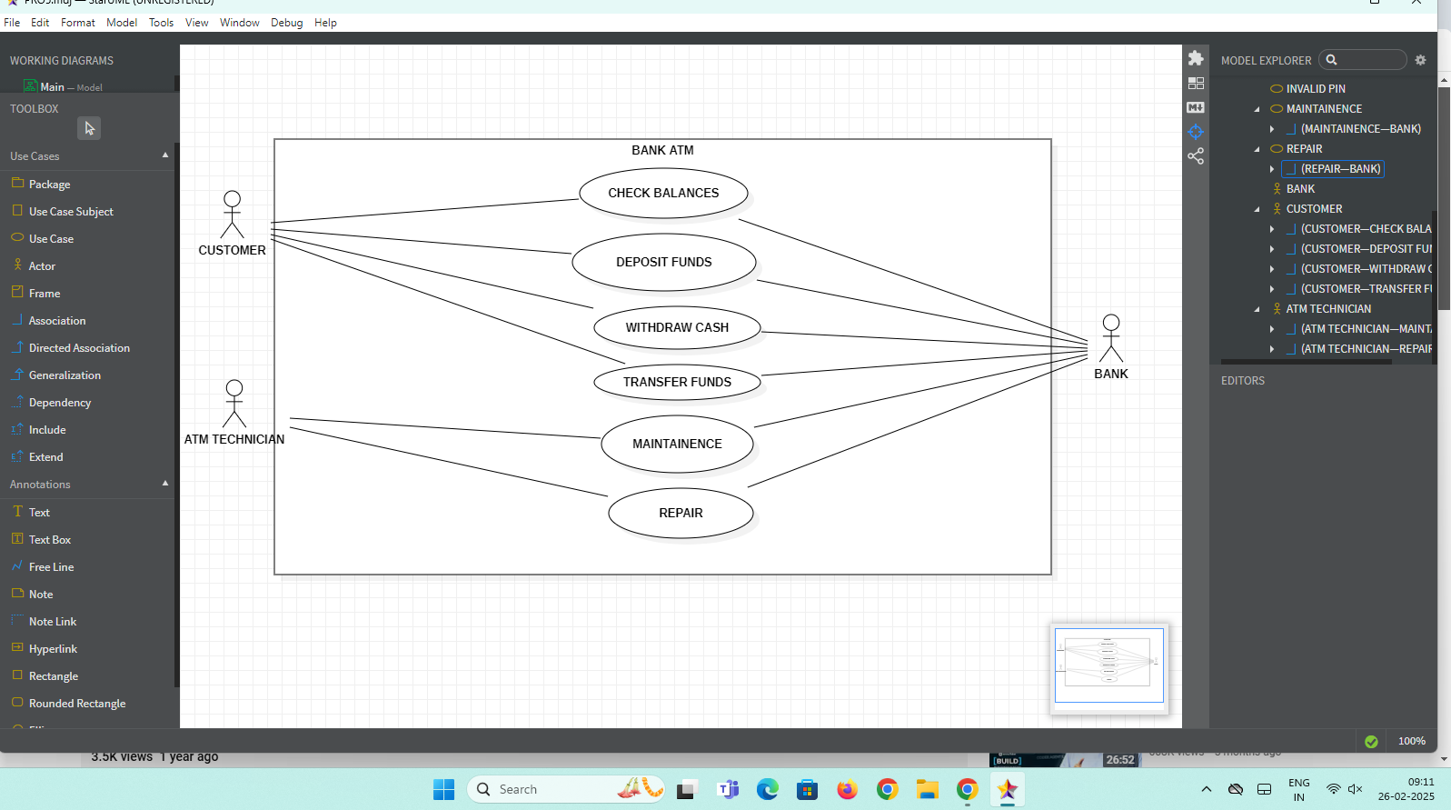

LIBRARY SYSTEM

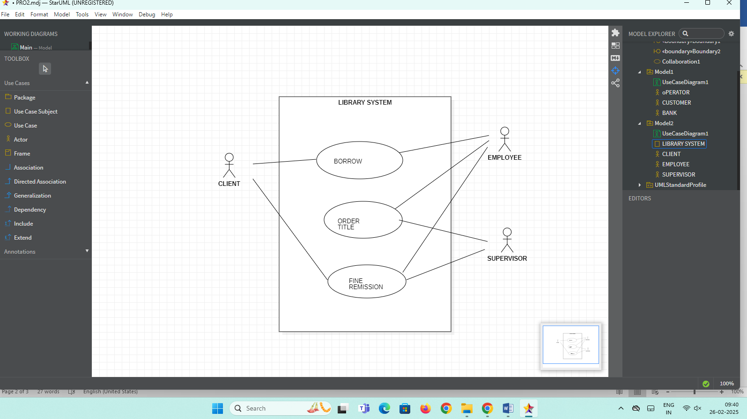

ORDER MANAGEMENT SYSTEM

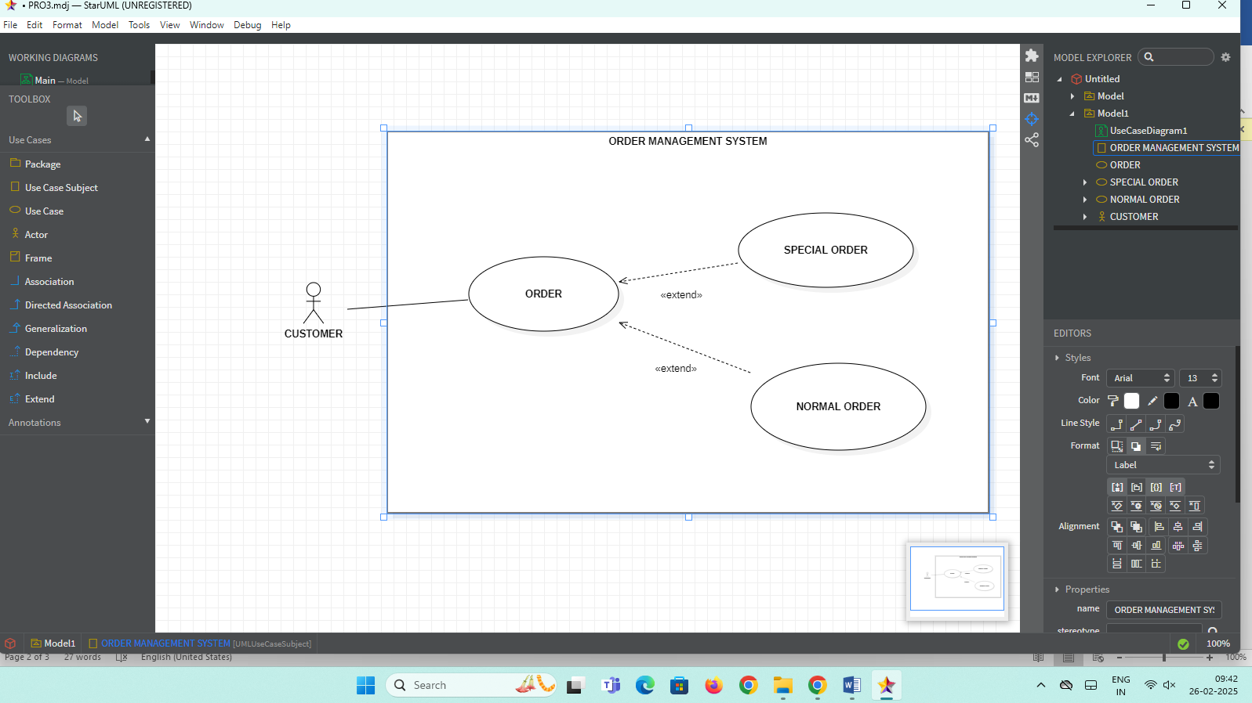

ATM SYSTEM

